**A**

**PROJECT REPORT**

**ON**

# Dynamic Website of Covid-19 Information

**IN PARTIAL FULFILLMENT FOR THE BACHELOR DEGREE COURSE**

**IN**

## COMPUTER ENGINEERING



**SUBMITTED BY**

**GIRAMKAR SHRUSHTI ANKUSH**

**BHOSALE SAIEE PRAMOD**

**SONAWANE PRATHAMESH NITIN**

**TUPE MANISHA NANA**

UNDER THE GUIDANCE OF

Dr. Suryawanshi. P.M

**DEPARTMENT OF COMPUTER ENGINEERING**

**HSBPVT’S PARIKRAMA COLLEGE OF ENGINEERING, KASHTI**

**HSBPVT’s GOI Faculty of Engineering, Kashti**

DEPARTMENT OF COMPUTER ENGINEERING, KASHTI



This is to certify that **Miss. Giramkar Shrushti Ankush** from **Fourth Year Computer Engineering** has successfully completed her seminar work titled **“Software Testing & Quality Assurance Mini Project”** HSBPVT College of Engineering, Kashti in the partialfulfilment of the Bachelor’s Degree in Engineering of Savitribai Phule Pune University.

Dr. Suryawanshi.P.M Proff. Sayyad. J.I Dr. Mahadik.S.N. N

**Guide Name HOD Principal**

## 

## ACKNOWLEDGEMENT

Just a few months ago we were living a completely different life unaware of how rapidly things were going to change. The Coronavirus is a global disturbance that has forced us all to come together and try to put an end to it. While we are all making changes and doing what we can to help, there is still a lot more that needs to be done. We’ve seen some apps and websites pop up to try and provide information to help fight this COVID-19 coronavirus pandemic.

If you want to join in the fight this is the time to create a website and an app [t](https://softwaredevelopersindia.com/contact-us/)hat provides information globally but also could actually help put an end to this. To help guide you, here is a list of information you should provide.

We extend our gratitude to Department of Geomatics Engineering, Kathmandu University for entrusting us with this project and their support. We would like to express our sincere gratitude to our supervisors Er. Dinesh Bhatta and Er. Basanta Awasthi for their support and invaluable suggestions during the project. Lastly, we would like to thank everyone who has helped us directly and indirectly for successfully completing this project

### CONTENTS

|  |  |  |  |
| --- | --- | --- | --- |
| Sr.  No |  | Title | Page No. |
| 1 | Abstract |  | 5 |
| 2 | Introduction |  | 6 |
| 4 | Problem Statements |  | 7 |
| 5 | Objectives |  | 7 |
| 6 | Future scope |  | 9 |
| 7 | Literature Survey |  | 10 |
| 8 | Proposed System Design |  | 11 |
| 9 | Implementation and Evolution |  | 12 |
| 10 | output |  |  |
| 11 | Evolution and Experimentation |  |  |
| 12 | Conclusion and Future Work |  | 13 |
| 13 | Reference |  | 14 |

## Abstract

This report has been prepared on the project of topic-Emergency COVID-19 Handling by the students of Geomatics Engineering (first year-second semester) of Kathmandu University.

This is an outcome for the project launched under the department of Geomatics Engineering, a two-credit course for first year of undergraduate studies. The main objective of this project is to study timely trend of COVID-19 in home districts of the students (allocated group) along with the comparative study of situations.

A novel coronavirus (Co-V) named ‘2019-nCoV’ or ‘2019 novel coronavirus’ or ‘COVID-19’ by the World Health Organization (WHO) is in charge of the current outbreak of pneumonia that began at the beginning of December 2019 near in Wuhan City, Hubei Province, China [1–4]. COVID-19 is a pathogenic virus. From the phylogenetic analysis carried out with obtainable full genome sequences, bats occur to be the COVID-19 virus reservoir, but the intermediate host(s) has not been detected till now.

## Introduction

Coronavirus disease 2019 (COVID-19) is an infectious disease caused by severe acute respiratory syndrome coronavirus 2 (SARS-CoV-2). It was first identified in December 2019 in Wuhan, China, and has resulted in an ongoing pandemic. The first case may be traced back to 17 November 2019. As of 8 June 2020, more than 6.98 million cases have been reported across 188 countries and territories, resulting in more than 401,000 deaths. More than 3.13 million people have recovered. The virus is primarily spread between people during close contact, most often via small droplets produced by coughing, sneezing, and talking. The droplets usually fall to the ground or onto surfaces rather than travelling through air over long distances.

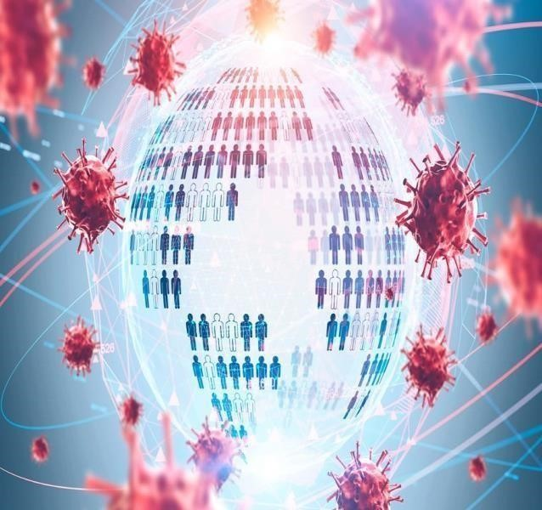

Less commonly, people may become infected by touching a contaminated surface and then touching their face. It is most contagious during the first three days after the onset of symptoms, although spread is possible before symptoms appear, and from people who do not show symptoms. The virus is primarily spread between people during close contact, most often via small droplets produced by coughing, sneezing, and talking. The droplets usually fall to the ground or onto surfaces rather than travelling through air over long distances. Less commonly, people may become infected by touching a

contaminated surface and then touching their face. It is most contagious during the first three days after the onset of symptoms, although spread is possible before symptoms appear, and from people who do not show symptoms.

Corona virus widely known as COVID-19 are a large family of viruses that are known to cause illness ranging from the common cold to more severe diseases such as Middle East Respiratory Syndrome (MERS) and Severe Acute Respiratory Syndrome (SARS)

The virus out-braked on Nov-2019 from Wuhan city of china. The virus affected south China for about a month and then it spread throughout the world making the path through Europe. The champion’s league game between Atlanta and Valencia became the poison for spreading the virus in Europe as more than 80,000 spectators were in stadium. Till date, the virus had spread in about 235 territories affecting more than 55 million of population.

Nepal also reported its first COVID-19 case on 23 January 2020 which today tallied to 208,299 cases. The timely imposing of the lockdown controlled the chances of rapid incrementation of infected population till June. But with the foreign manpower being brought to home country and loosening of lockdown after July, the number of infected populations increased in the exponential way.

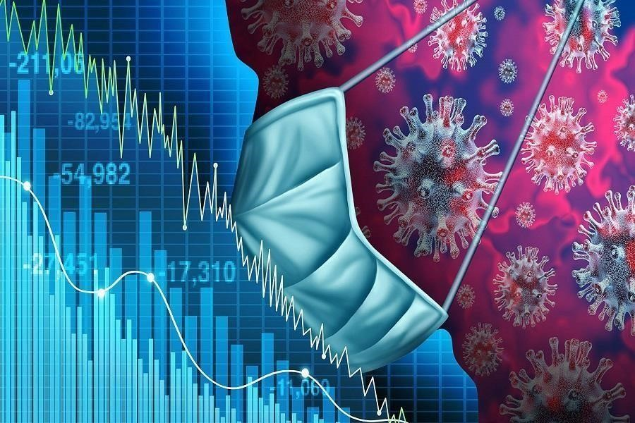

The large number of people are being infected and killed on daily basis all over the world. And the data of death, infected and recovered cases are being provided on different websites, Google, webpages etc.

But these data are only limited to national and international level. Therefore, with the necessity to bring the data of local level with effective analysis, and to make a project work possible through virtual classes we the students of Geomatics engineering were assigned with project “Emergency Handling of COVID-19 in Home Districts”. We all were divided into different groups with 5 members from 5 different districts in each.

## Problem Statements

In this project we dived deep into ‘What does data say about Covid-19 situation in India?’. And with available data we came up with some observations and conclusions. This analysis mainly focuses on:

✔What is the current COVID-19 situation in India?

✔State-wise comparison.

✔What could be the reasons behind cases clusters found in India.

✔Is lockdown in India successful or not?

## Objectives

1. The primary objective of our project is:

* To study timely trend of Covid-19 in our home districts along with the comparative study

of situations.

1. The secondary objectives of our project are:

* To determine the possible analytical outcomes of COVID-19 situations

based on different age groups and other divisions.

* To study and evaluate the provided facilities, works done to minimize the

effect and spreading of virus from a local level.

* To develop the idea and concept of teamwork, field project and analytical

skills to us.

## Scope

We have collected the COVID-19 data through different sources. We have used the official website of Ministry of Health and Population, CDO Offices of individual home districts, and Municipality’s website.

We have refined, and analyzed those data in different aspects and displayed it in a systematic form. So this report/project can be helpful to different students who are doing COVID -19 research and project of different districts. Similarly, local level bodies can utilize it to study the pattern of COVID-19 and formulate the further plans as per need.

**LITERATURE SURVEY**

**RESEARCH PAPER REFERRED**

1. Covid-19 impact on Indian Economy Authors:
   * S. Mahindra Dev (Indira Gandhi Institute of Development Research)
   * Rajeshwari Sengupta (Indira Gandhi Institute of Development Research) <https://ideas.repec.org/p/ind/igiwpp/2020-013.html>
2. COVID-19 in India: Potential Impact of the Lockdown and Other Longer-Term Policies Authors:
   * Emily Schuler (CDDEP)
   * Eili Klein (Department of Emergency Medicine, Johns Hopkins School of Medicine; CDDEP)
   * Gary Lin (Department of Emergency Medicine, Johns Hopkins School of Medicine <https://cddep.org/wp-content/uploads/2020/04>

**DATA SOURCES**

For the COVID-19 data we have scrapped https://api.covid19india.org which is a volunteer-driven, crowdsourced database for COVID-19 stats & patient tracing in India.

**For facts and information we have referred** [**www.wikipedia.com a**](http://www.wikipedia.com/)**nd** [**www.twitter.com**](http://www.twitter.com/)

## PROPOSED SYSTEM DESIGN:

India recorded its first COVID-19 case on 30th January 2020 in Kerala. The infected person was a student who had travelled to china for academic purpose. And since then cases in India is rising exponentially.

**What is the current situation in India?**

That kind of situation, where we don't keep social distancing, will usually keep coming back to hurt you. There are other reasons. If you look at second waves historically, they've always been more aggressive and bigger in number than the first. The intensity this time round, though, is more about the overbearing requirement for people to have two things. Firstly, the need to get into a hospital and have a bed with oxygen where they can feel a bit secure. And secondly, the amount of anxiety that comes from not getting a bed.

That has been the overwhelming sentiment of most people who may or may not need hospitalisation, but feel it is the most secure place for them.

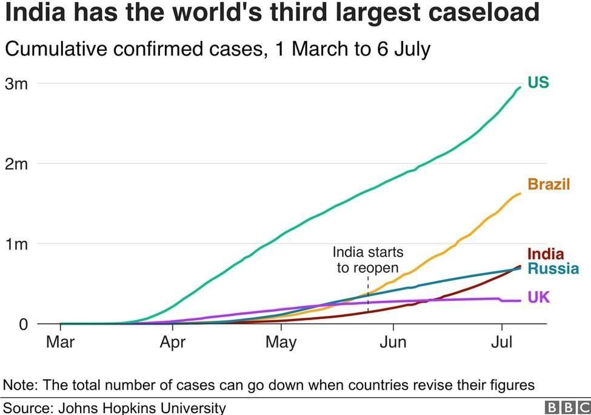

**Age wise COVID -19 data:**

This line chart shows the age wise COVID cases of both male and female in Lalitpur district. From the line chart we can see that age between 0-20 and 70+ are not much infected. Because these age group include children, teenager and old people who are quite safe these days in their home due to closed schools, colleges, universities, temples, etc. How else the age interval of 21-50 are more infected because people of these age group are active, matured and they involved in different profession. They work in different places so they travelled more due to which they come in contact of different people. Hence, they are more infected.

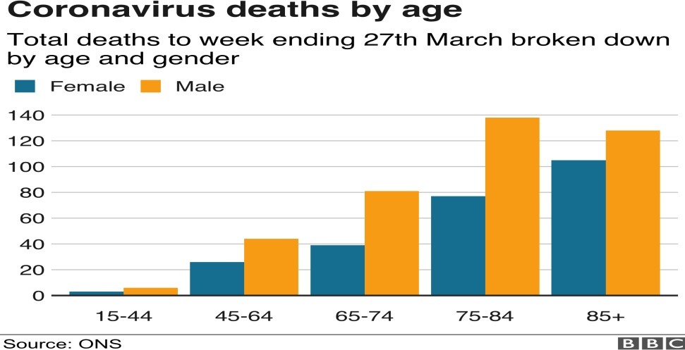

**Overall status of the District:**

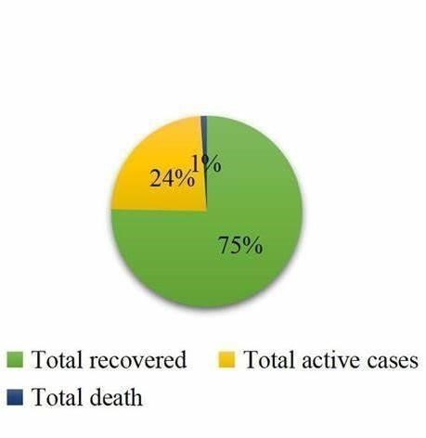

**Implementation and Evaluation**

<!doctype html>

<html>

<head>

<meta name="viewport" content="width=device-width, initial-scale=1">

<!--Critical to responsive design-->

<meta charset="utf-8">

<title>

Covid-19 Information about symptom precution impact

</title>

</head>

<link rel="stylesheet" href="layout.css">

<body>

<header>

<nav>

<ul>

<li><a href="">Home</a></li>

<li><a href="http://127.0.0.1:5500/About/About%20us/about-

us.html">About</a></li>

<li><a

href[="http://localhost/PhpPrograms/Contact%20database/contact.php">](http://localhost/PhpPrograms/Contact%20database/contact.php)Contact</a></li>

`<li><a href[="http://localhost/PhpPrograms/Register/index.php "](http://localhost/PhpPrograms/Register/index.php)>Login</a></li>

<li><a href[="http://localhost/PhpPrograms/Register/logout.php "](http://localhost/PhpPrograms/Register/logout.php)>Logout</a></li>

</ul>

</nav>

</header>

<section class="home-hero">

<!--container class used to ensure contents do not touch edge of box see css

-->

<div class="container">

<h1 class="title"><span class="animate">Covid-19</span> </h1>

<h2><span class="animate">Stay Home, Stay Safe!!! </span></h2>

<a href="http://127.0.0.1:5500/Let's%20friendly%20button/index.html" class="button button-

accent"> Let's Friendly With Covid-19</a>

</div>

</section>

<div class="container">

<section class="home-about">

<div class="home-about-textbox">

<h1>

Don't Panic....

</h1>

<p>

Better to Wear a Mask Than a Ventilator,<br> Better to Stay at Home Than in ICU!!!!

</p>

</div>

</section>

</div>

<section class="portfolio">

<h1>

Bring the Changes !- Be the Changer!

</h1>

<!--portfolio item #1-->

<figure class="port-item">

<img src="educationtech.jpeg" alt="portfolio item">

<figcaption class="port-description">

<p>

Impact On Education

</p>

<a href="http://127.0.0.1:5500/Impats/educational.html" class="button button-accent button-

small">See in detail</a>

</figcaption>

</figure>

<!--portfolio item #2-->

<figure class="port-item">

<img src="industry.jpg" alt="portfolio item">

<figcaption class="port-description"> <p></p>

<a href="http://127.0.0.1:5500/Impats/industry.html" class="button button-accent button-

small">See in detail</a>

</figcaption>

</figure>

<!--portfolio item #3-->

<figure class="port-item">

<img src="farmer.jpeg" alt="portfolio item">

<figcaption class="port-description">

<p>

Impact On Farmers

</p>

<a href="http://127.0.0.1:5500/Impats/Farmer.html" class="button button-accent button-

small">See in detail</a>

</figcaption>

</figure>

<!--portfolio item #4-->

<figure class="port-item">

<img src="scienceresurch.jpeg" alt="portfolio item">

<figcaption class="port-description">

<p>

Impact On Science and Technology

</p>

<a href="http://127.0.0.1:5500/Impats/science_tech.html" class="button button-accent button-

small">See in detail </a>

</figcaption>

</figure>

<!--portfolio item #5-->

<figure class="port-item">

<img src="coronaecon.jpg" alt="portfolio item">

<figcaption class="port-description"> <p>

Impact On Indian Economy

</p>

<a href="http://127.0.0.1:5500/Impats/Indian_economy.html" class="button

button-accent button-small">See in detail </a>

</figcaption>

</figure>

<!--portfolio item #6-->

<figure class="port-item">

<img src="security.jpeg" alt="portfolio item">

<figcaption class="port-description">

<p>

Impact On Security

</p>

<a href="http://127.0.0.1:5500/Impats/Security.html" class="button button-accent button-

small">See in detail</a>

</figcaption> </figure> <!--portfolio item #7-->

<figure class="port-item">

<img src="transportation.jpeg" alt="portfolio item">

<figcaption class="port-description"> <p>

Impact On Transportation

</p>

<a href="http://127.0.0.1:5500/Impats/Transportation.html" class="button

button-accent button-small">See in detail</a>

</figcaption>

</figure>

<!--portfolio item #8-->

<figure class="port-item">

<img src="contriesimp.jpeg" alt="portfolio item">

<figcaption class="port-description"> <p>

Impact On Different Contries

</p>

<a href="http://127.0.0.1:5500/Impats/diff_countries.html" class="button

button-accent button-small">See in detail</a>

</figcaption>

</figure>

<figure class="port-item">

<img src="environment nd tourism.jpeg" alt="portfolio item"> <figcaption class="port-description">

<p>

Impact On Environment & Tourism

</p>

<a href="http://127.0.0.1:5500/Impats/Environment_turism.html" class="button

button-accent button-small">See in detail</a>

</figcaption>

</figure>

</section>

<section class="cta">

<div class="container">

<h1 class="title title-cta">Make your Contribution!

<span>

Let's Work Together To Aware People About Covid-19!... </span>

</h1>

<a href[="http://localhost/PhpPrograms/contributionForm/form.php"](http://localhost/PhpPrograms/contributionForm/form.php) class="button button-

dark">Get Started</a>

</div> </section> <footer>

<div class="container">

<div class="col-3">

<!--footer paragraph-->

<p> This is an initative to Spread Awareness about Covid-19</p>

</div>

<!--footer link2-->

<div class="col-1">

<ul class="unstyled-list">

<li><strong> Events</strong></li>

<li> Registration</li>

<li>Plays</li>

<li>Precautions drive</li>

<li> clean up drive</li>

</ul>

<a href[="http://localhost/PhpPrograms/comments/comment.php "](http://localhost/PhpPrograms/comments/comment.php) class="button button1-dark

button-small">

<span class="animate"> Comments </span></a>

</div>

</div>

</footer>

</body>

</html>

## Output:

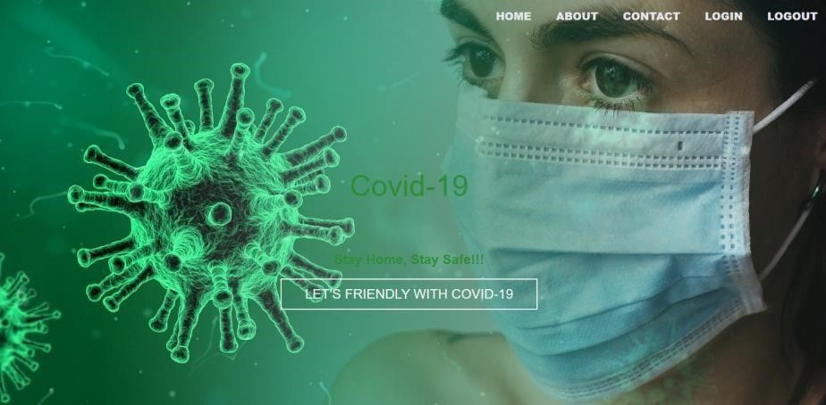

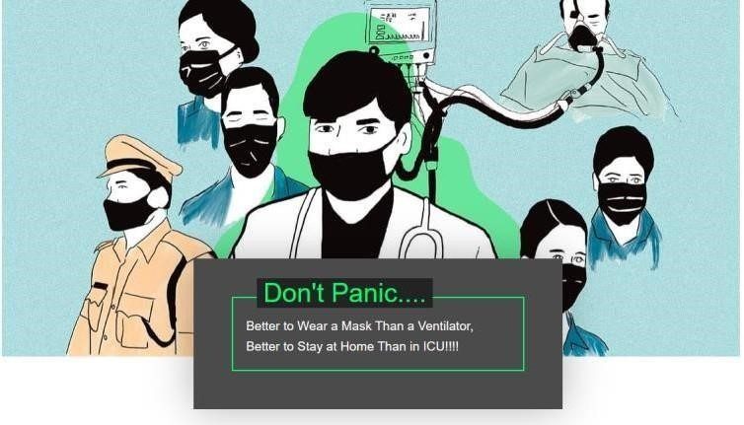

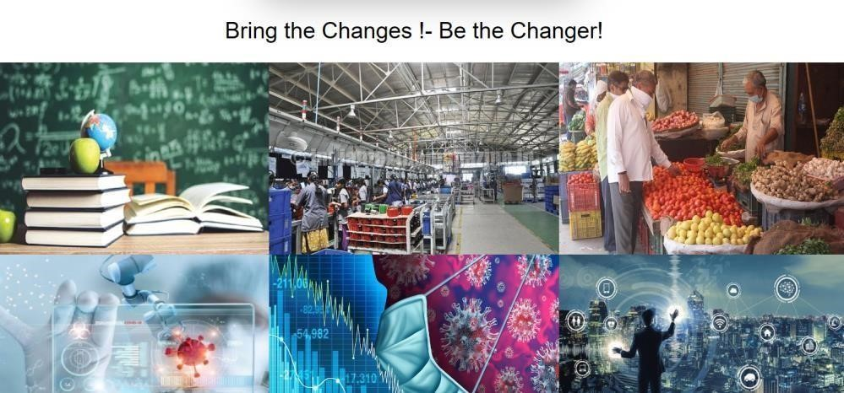

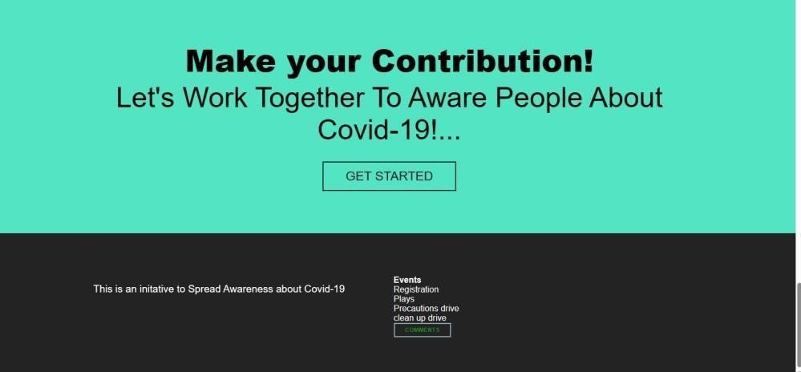

## Evaluation and Experimentation

**Open Access** This article is licensed under a Creative Commons Attribution 4.0 International License, which permits use, sharing, adaptation, distribution and reproduction in any medium or format, as long as you give appropriate credit to the original author(s) and the source, provide a link to the Creative Commons licence, and indicate if changes were made.Use is not permitted by statutory regulation or exceeds the permitted use, you will need to obtain permission directly from the copyright holder.

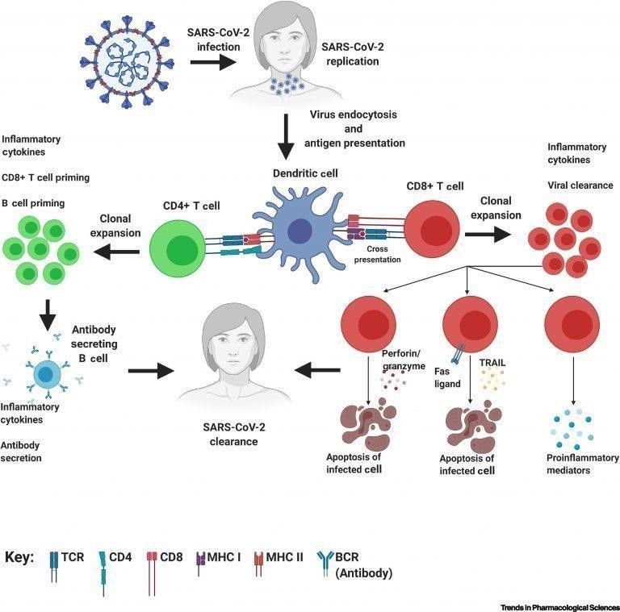

## Conclusion and Future Work

Hence in this project we collected both the qualitative and the quantitative COVID-19 infection data of five major districts. The quantitative data studied the COVID cases in different aspects such as gender, age etc. and qualitative data evaluate the socioeconomic situation, health facilities, infected cases and individual perception towards this pandemic.

Similarly, comparative study of five districts concludes that male members of age group 21-30 are highly infective than other due to their active involvement in socioeconomic activities, high mobility, high population. As people are not following all the safety protocols and also the availability of excessive testing technologies results in more infected cases in different district. Also the study show that there is high recovery rate than infected and death rate.

Taking the present situation as new normal way of living they are showing negligence toward the COVID-19 Virus. Likewise, this project helped every one of us to be familiar with our home districts, the situation of COVID pandemic, different software. Moreover, it taught a lot about the essence of planning, cooperation during the team works. This type of project can be best way of collecting, analyzing and visualizing the COVID 19 cases and its impact in different aspects of community.

Hence, this is the high time, so we all need is patience, unity and cooperation to fight against the situation.

### 

### References

* Ministry of Health and Population. (2020). Retrieved November 03, 2020, from <https://covid19.mohp.gov.np/>
* District Coordination Committee Japan. (2020). Retrieved October 30, 2020, from [https://dccjhapa.com.np](https://dccjhapa.com.np/)
* District Administration Office Lalitpur. (2020). Retrieved November 1, 2020, from <https://daolalitpur.moha.gov.np/>
* District Administration Office Bhaktapur. (2020) Retrieved October 30, 2020, from <https://daobhaktapur.moha.gov.np/en>
* District Administration Office Khachapuri. (2020). Retrieved November 01, 2020, from<https://daokanchanpur.moha.gov.np/>
* District Administration Office Dadeldhura. (2020). Retrieved October 30, 2020, from <https://daodadeldhura.moha.gov.np/>